CSIT 321 - Project


CSIT 321 - Project

User Manual

Project Topic: CSIT-24-S3-08

(Multi-factor transaction authorisation based on QR code)

Group Number: FYP-24-S3-11

Member’s Name | UOWID | Email
Matthew Chin Yu Kang | 7768990 | mykchin001@mymail.sim.edu.sg
Randall Lim Shi Hao | 8107002 | rshlim001@mymail.sim.edu.sg
Teo Wei Zhi Zakary | 7769258 | wzzteo001@mymail.sim.edu.sg
Mahina Lim Fong Jia | 8378885 | mfjlim002@mymail.sim.edu.sg
Ryzlan Afiq Bin Roslan | 7895124 | ryzlanab001@mymail.sim.edu.sg

Supervisor
Mr Chua Zong Fu

Assessor
Mr Japit Sionggo

Table of Contents

Table of Contents 2
1. Introduction 4
2. System Requirements 5
2.1 User requirements 5
2.2 Mobile Requirements 5
3. Installation Instructions 6
3.1 How To Install 6
3.2 Deployment Instructions 6
4. How to use Room Booking as a user/director 7
4.1 Login Page 7
4.1.1 Webpage Login 8
4.1.2 Mobile Login 10
4.2 User/Director Menu 11
4.2.1 Book a room 11
4.3 Bookings Menu 13
4.3.1 Amend Booking 13
4.3.2 Cancel Booking 14
4.4 Feedback Menu 14
4.4.1 Leave Feedback 15
4.5 Favourites Menu 16
4.5.1 Book Room From Favourites 16
4.6 User/Director Navbar 17
4.6.1 User/Director Settings 17
4.6.1.1 Change Password 17
4.6.2 User/Director Logout 18
4.7 Mobile Menu 19
4.7.1 Scan Biometrics 20
4.7.2 Logout from Mobile 20
5. How to use Room Booking as an admin 21
5.1 Admin Login 21
5.1.1 Admin Webpage Login 21
5.1.2 Admin Mobile Login 21
5.2 Admin Menu 22
5.3 Admin Navbar 23
5.3.1 Admin Settings 23
5.3.1.1 Change Password 24
5.3.2 Admin Logout 24
5.4 Admin Manage Users Menu 25
5.4.1 Add User 25
5.4.2 User Management 26
5.4.2.1 Edit User 26
5.4.2.2 Terminate User 26
5.4.2.3 Unlock User 27
5.5 Admin Manage Rooms Menu 27
5.5.1 Add Room 29
5.5.2 Room Management 29
5.5.2.1 Edit Room 29
5.5.2.2 Delete Room 30
5.5.2.3 View Feedback 30
5.6 Admin Mobile Menu 31
5.6.1 Access QR Code 32
5.6.2 Admin Logout from Mobile 33

1. Introduction
A transaction is a fundamental interaction or exchange between parties where something of value, such as goods, services, money, or information, changes hands based on mutual agreement regarding the terms and conditions. Transactions are integral to various contexts, including financial markets, business operations, and everyday interactions, providing the basis for economic activity and organisational efficiency.
In our project, transactions play a crucial role in the booking system for meeting rooms. When a user selects a date and time to reserve a room, a transaction is initiated to exchange information and verify availability. This involves a seamless process where the application checks the room's availability, generates a QR code for the confirmed booking, and triggers multi-factor authentication (MFA) to ensure secure user confirmation. This series of interactions ensures that the booking is accurately recorded and that only authorised users can access the reserved meeting room.
This project aims to create a secure and efficient room booking system that leverages modern technologies to facilitate transactions. By integrating real-time availability checks, QR code generation, and MFA, the system ensures that the booking process is user-friendly and secure. This approach not only enhances user experience but also improves the overall management of meeting room reservations, contributing to better organisational efficiency and resource utilisation.

2. System Requirements
Before using AuthBook, please make sure your computer meets the following requirements:
Processor: Any cpu with at least 4-core, 8 threads.
RAM: At least 8 GB RAM.

2.1 User requirements
- Users are required to have a fairly recent web browser, such as:
  - Mozilla Firefox
  - Google Chrome
  - Microsoft Edge
- Users must be able to use the application on Android OS.
- Users need a working email address to utilize the features of the system effectively.

2.2 Mobile Requirements
- Your mobile device will require a biometric function to allow AuthBook to verify your identity and provide you with the PIN number for your room.
- A camera phone is required for scanning QR codes

3. Installation Instructions

3.1 How To Install
To install Room Booking, please follow these steps:
- Download the app from Google Play.
- The webpage will already be deployed, so it and the app are linked.
- Don’t worry about creating your own account - administration has already done that for you.

3.2 Deployment Instructions
We will be using Github and vercel.

Prerequisites
- A GitHub account with a repository for your project.
- A Netlify account.

Initialize Git and Create a Repository:
- In your project’s root folder, initialize a Git repository by running
  - $ git init
- Add all files to staging:
  - $ git add .
- Commit the changes:
  - $ git commit -m "Initial commit"
- Create a new repository on GitHub and follow the instructions to push your code:
  - $ git remote add origin https://github.com/username/repo-name.git
  - $ git push -u origin main
Verify the Repository:
- Go to your GitHub repository and confirm that all project files have been uploaded.

Connect GitHub to Netlify
Log in to Netlify:
- Go to vercel.com and log in or create an account.
Create a New Site from Git:
- On the Vercel dashboard, click "Add New Site" and select "Import an existing project".
Select GitHub as the Git Provider:
- Connect your GitHub account to Vercel if you haven't already. Authorize Vercel to access your GitHub repositories if prompted.
Select the Repository:
- Choose the repository you want to deploy from your list of GitHub repositories.

Configure Deployment Settings
- Choose the Branch:
  - Select the branch you want to deploy (usually main or master).
- Specify Build Settings:
  - Vercel often auto-detects the correct settings for common frameworks like Next.js, React, or Vue. If needed, you can enter the following manually:
    - Build Command: e.g., npm run build, pnpm build
    - Publish Directory: e.g., build or dist
- Environment Variables (Optional):
  - If your app requires environment variables, you can add them by going to the "Environment Variables" section under "Project Settings" on Vercel.

Deploy the Site
- Deploy:
  - Click "Deploy". Vercel will pull your code from the GitHub repository, build the site, and deploy it.
- Monitor the Deployment:
  - You can watch the deployment logs to ensure everything runs smoothly.

Verify and Update Site Settings
- Access Your Live Site:
  - Once deployment is complete, Vercel provides a unique URL for your site (e.g., your-project-name.vercel.app). Click the URL to preview your live site..
- Set Up a Custom Domain (Optional):
  - To use a custom domain, go to "Domains" under "Project Settings" in Vercel and add your custom domain. Vercel provides easy setup instructions for custom domain linking.
- Continuous Deployment:
  - Any future commits to your GitHub repository will automatically trigger a new deployment on Vercel. Simply push changes to your GitHub branch, and Vercel will update your live site accordingly.

Configure Mobile app
- Setup biometric in your mobile phone.

Deploy Spring boot on EC2
- Open Terminal in Visual Studio:
- Go to the top menu and select View > Terminal to open the terminal window.
- In the terminal, type the following command and press Enter:
(./gradlew clean build)
- This command will clean the previous builds and compile the project, generating the necessary build files.
- After the build completes successfully, navigate to the project directory. You should find the built file in the following path: ../build/libs
- Locate the file named roombooking-0.0.1-SNAPSHOT.jar in the libs
- Deploy in AWS EC2
- Open up terminal
- Connect to EC2 instance, replacing /path/to/your-key.pem with the path of your private key file and your-ec2-public-ip with the public IP of your instance:
ssh -i /path/to/your-key.pem ec2-user@your-ec2-public-ip
- Make sure Java is installed on EC2 with the following commands:
sudo yum update -y
sudo yum install java-1.8.0-openjdk -y
- Use SCP (Secure Copy Protocol) to upload your roombooking-0.0.1-SNAPSHOT.jar file from your local machine to the EC2 instance. Replace the paths accordingly:
scp -i /path/to/your-key.pem ../build/libs/roombooking-0.0.1-SNAPSHOT.jar ec2-user@your-ec2-public-ip:~
- Run the Spring Boot application with the following command:
java -jar roombooking-0.0.1-SNAPSHOT.jar

4. How to use Room Booking as a user/director
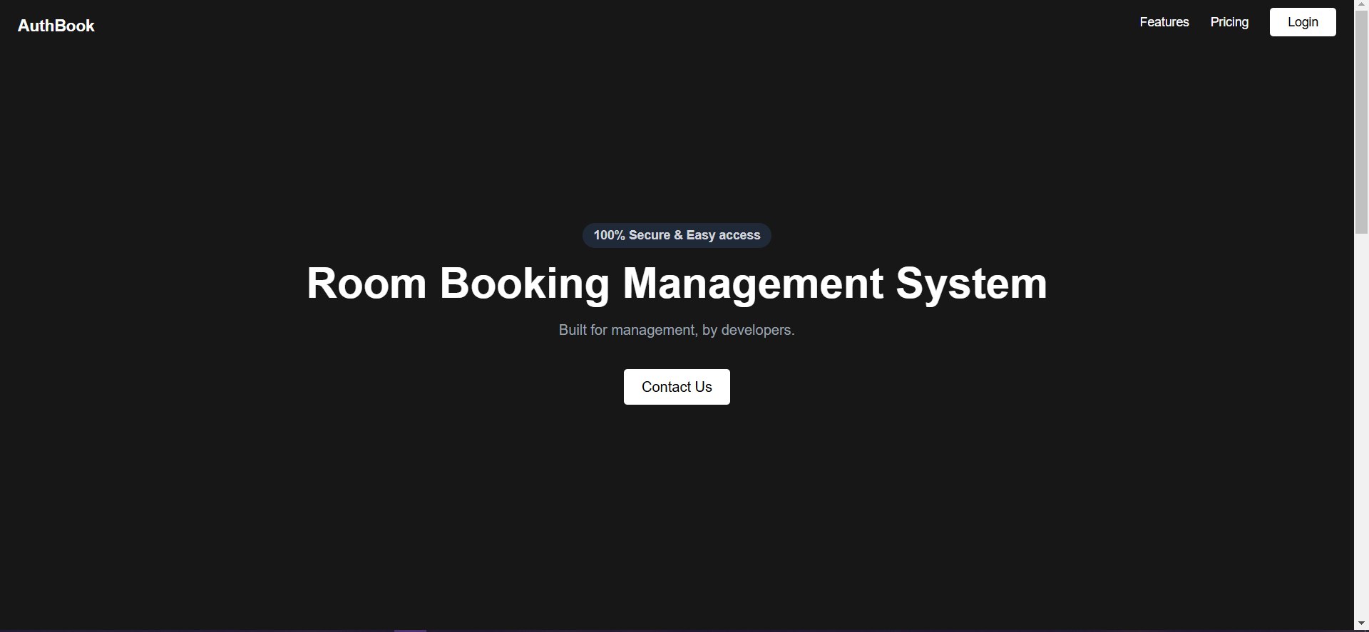

4.1 Login Page
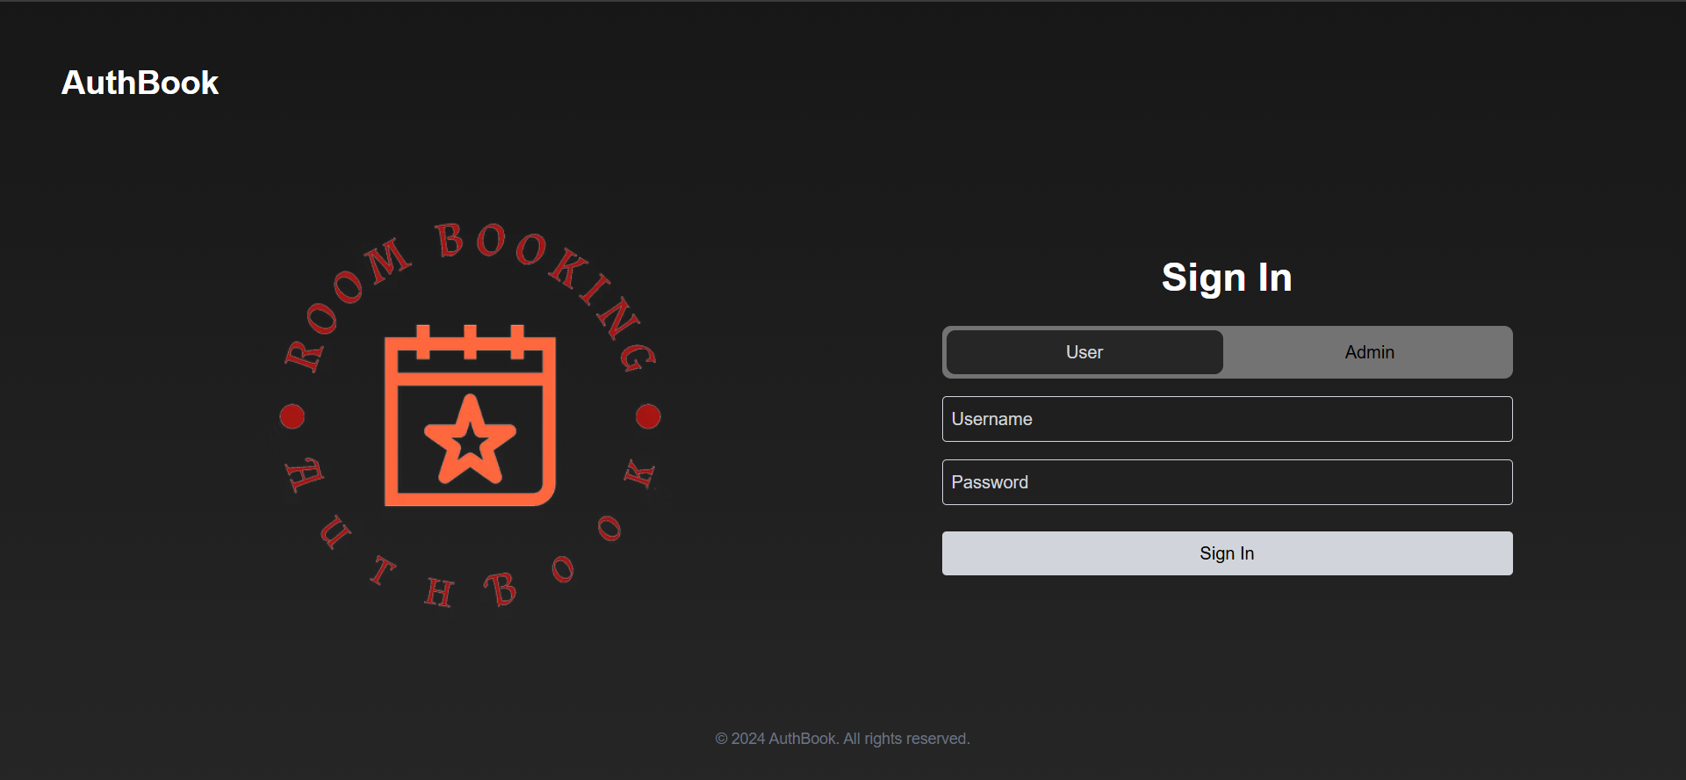
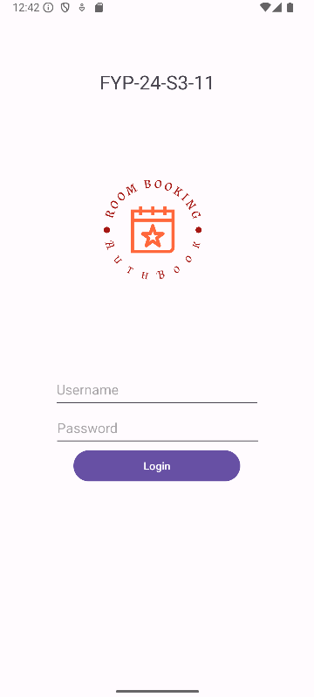
This is what the login page looks like on the mobile app.

Upon login success, you’ll be taken to the respective main menu. The main menu is meant to be easily navigable. You will have a different menu depending on whether you’re a user or an admin.

4.1.1 Webpage Login
- Enter your username and password.
- If you are a user or director, the notification below the Sign In button will tell you your role, and whether the login was a success or not.
- Repeated failures to login will result in the account getting locked out, which means having to contact an administrator to solve this.
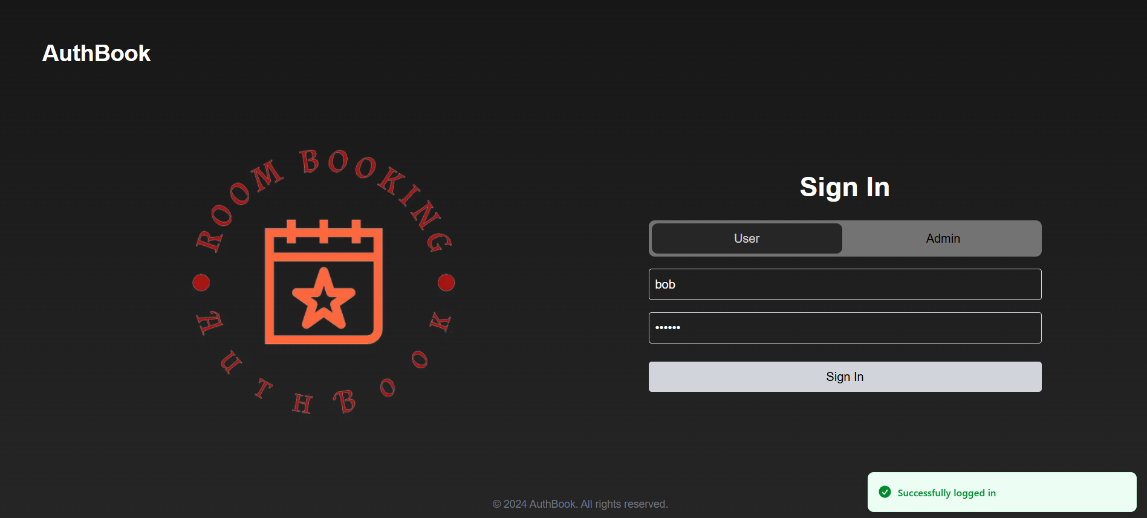

4.1.2 Mobile Login
- Enter your username and password
- Tap the purple Login button.
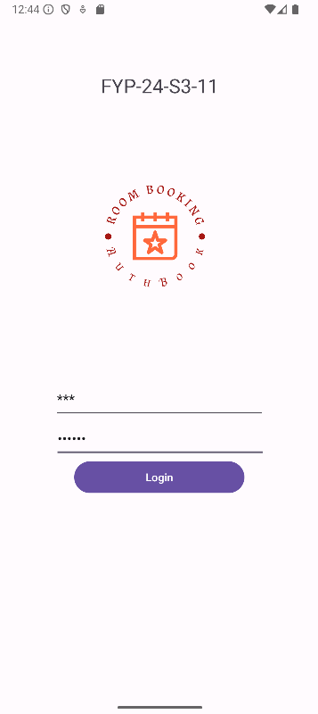

4.2 User/Director Menu
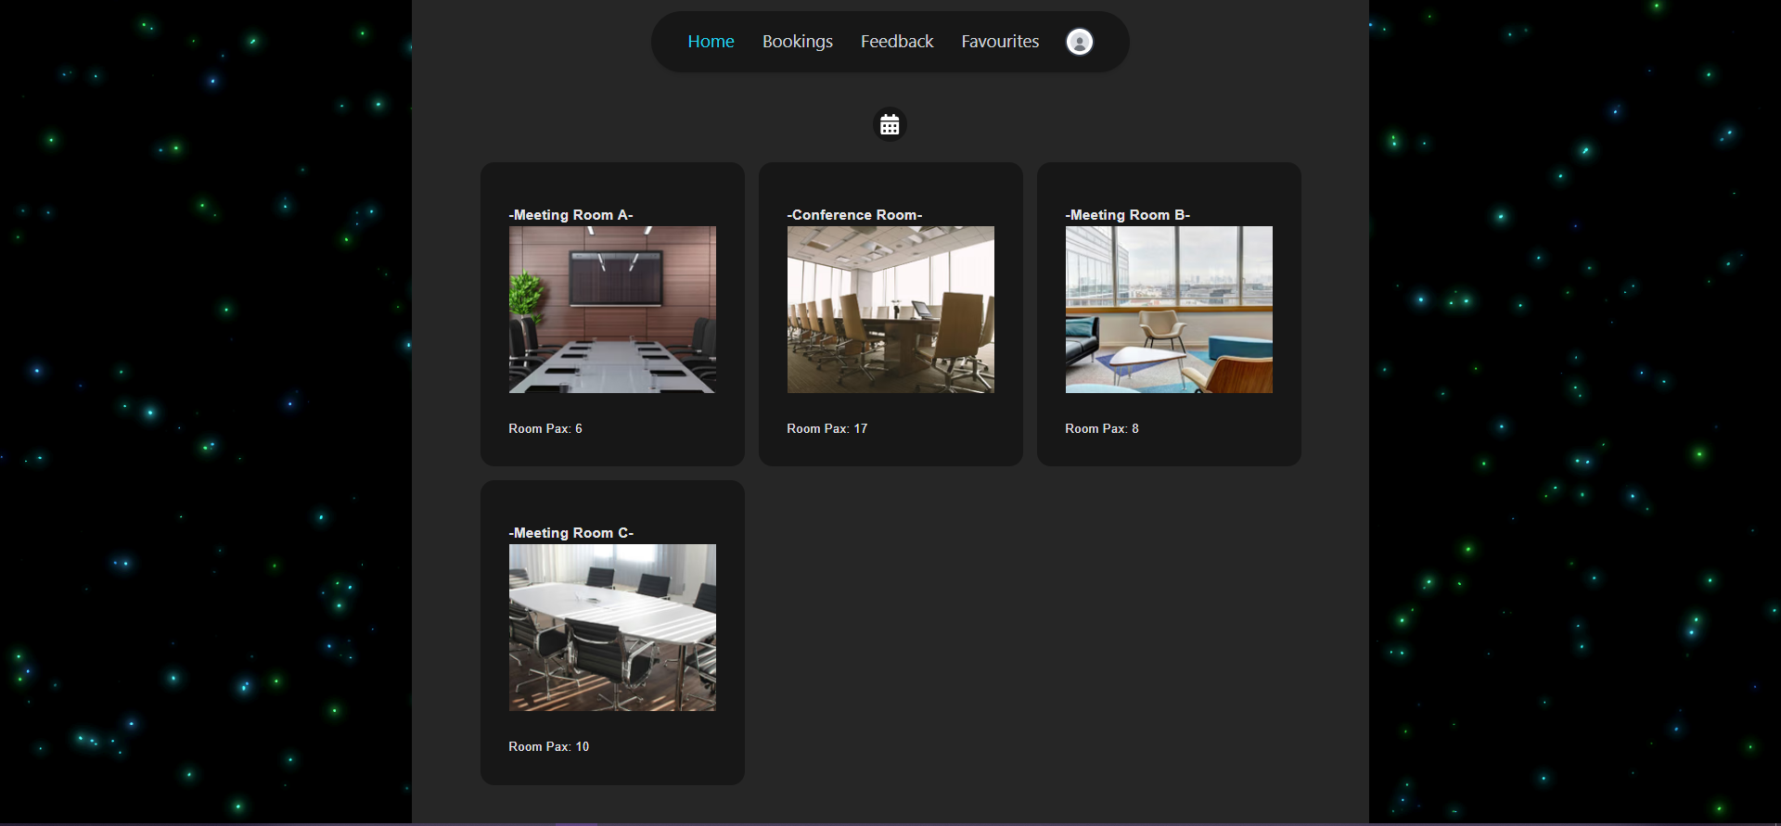
The Home page shows you the different kinds of rooms you can book.

4.2.1 Book a room
- Click the calendar icon to set the date and time of booking.
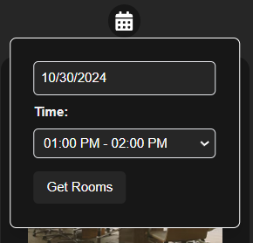
- Click on one of the rooms, and a popup will appear.
- Click on “Book Now” to finalize the process, or “Cancel” to halt it.
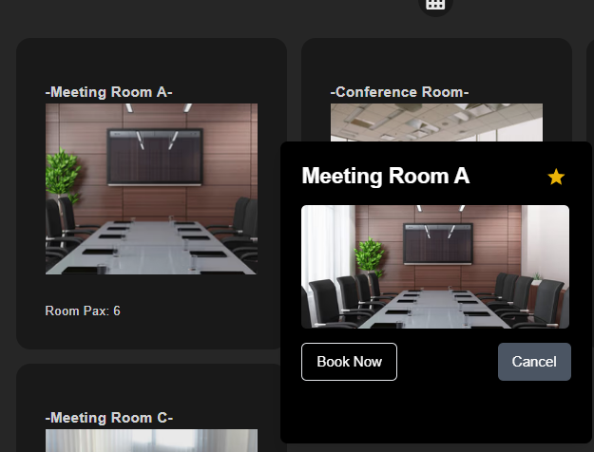
- You will be notified of the confirmation.
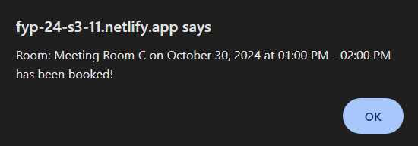
- If you wish, click on the star beside the room name to mark it as a favorite room.

4.3 Bookings Menu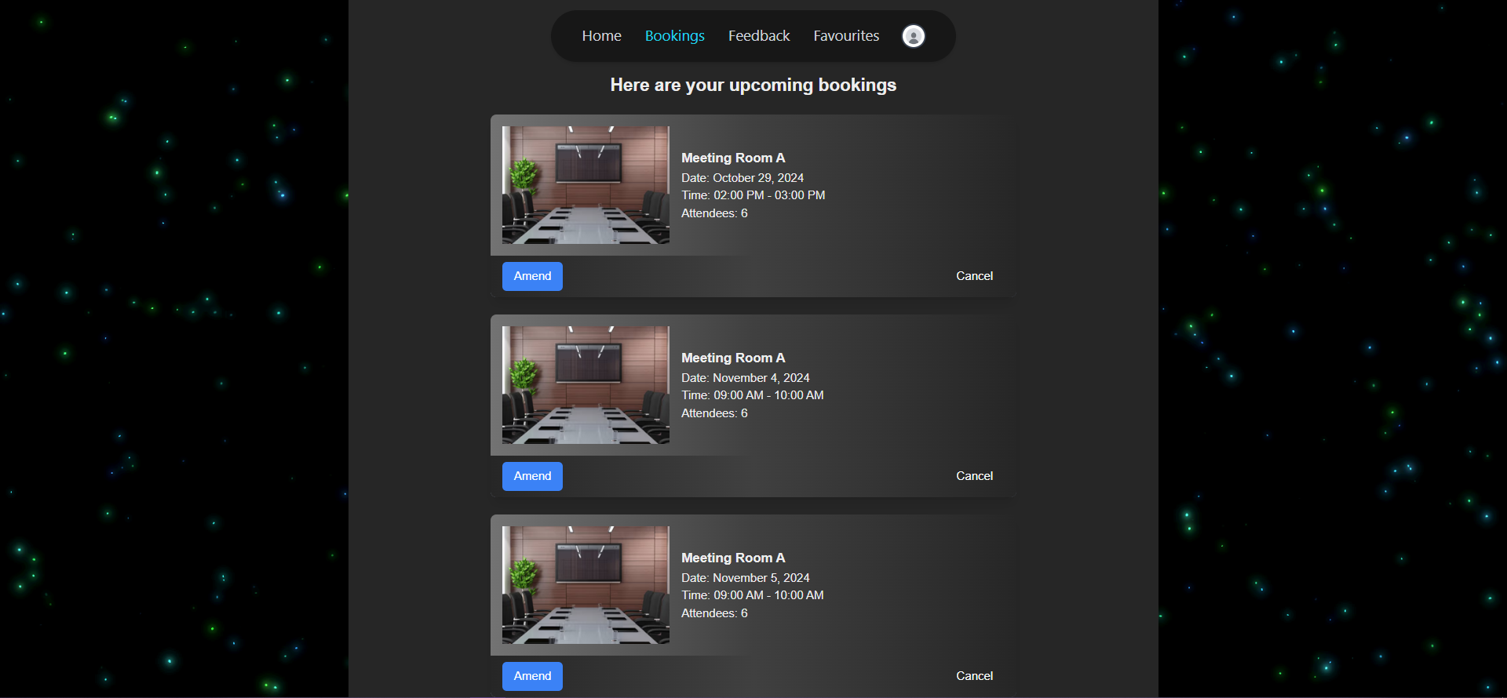
On the Bookings page, you can view the bookings you have made, make amends to them as needed, or cancel them entirely.

4.3.1 Amend Booking
- Click on the blue amend button.
- Modify the date and time of booking as you see fit.
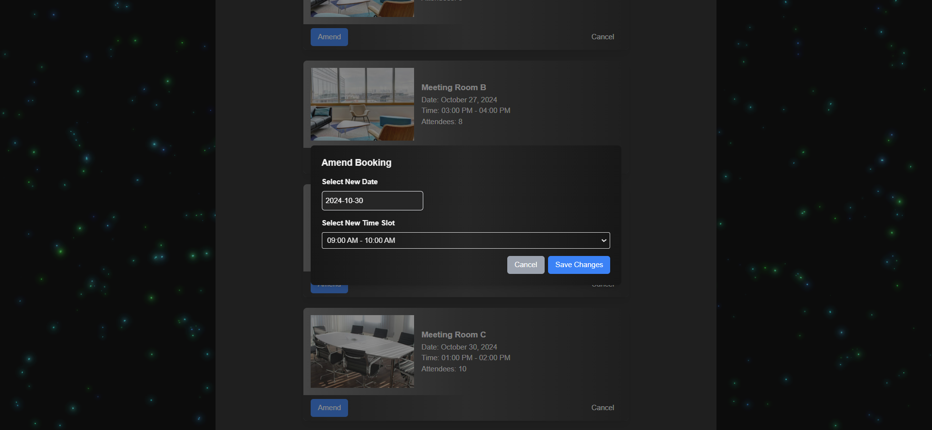
- Click on the blue Save changes button once you have done so, or Cancel to exit.
- You will be notified of the changes made.
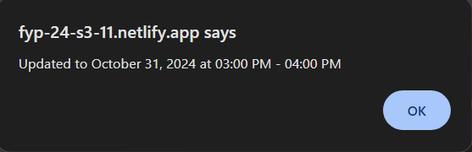

4.3.2 Cancel Booking
- Click on the Cancel button to remove a booking.
- The allotted booking will be removed.
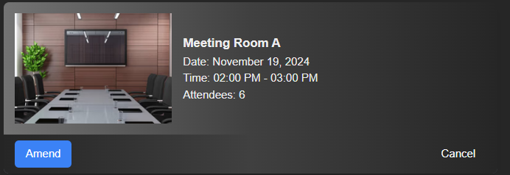

4.4 Feedback Menu
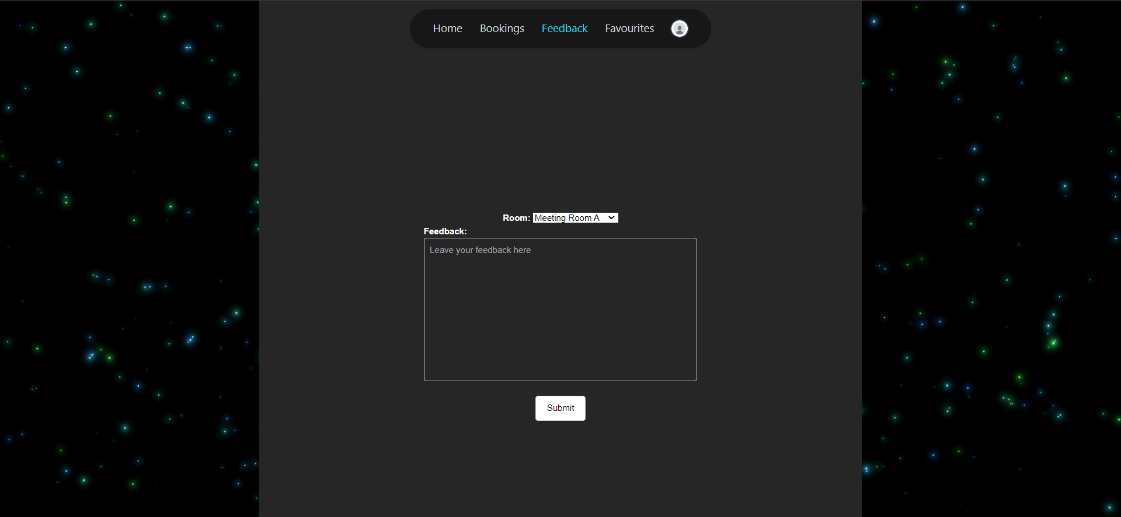
The Feedback page is where you can leave your opinions about each and every room you’ve experienced. It’ll be recorded for the viewing pleasure of the administrators.

4.4.1 Leave Feedback
- Select the room you wish to leave feedback for.
- Fill in the box once with the details of your feedback.
- Click the white Submit button and your feedback will be sent.
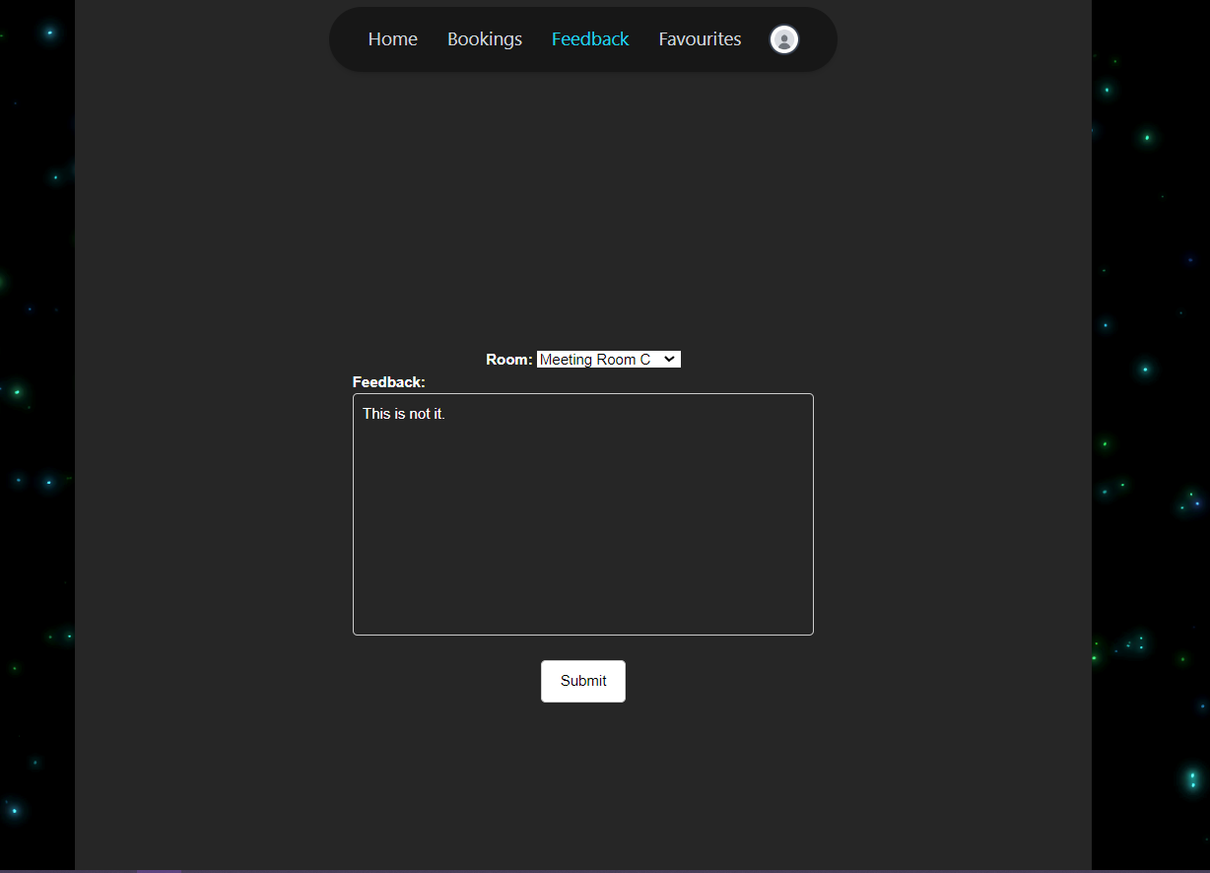
- You will be notified upon success.
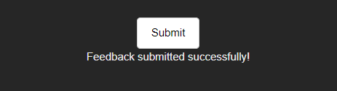

4.5 Favourites Menu
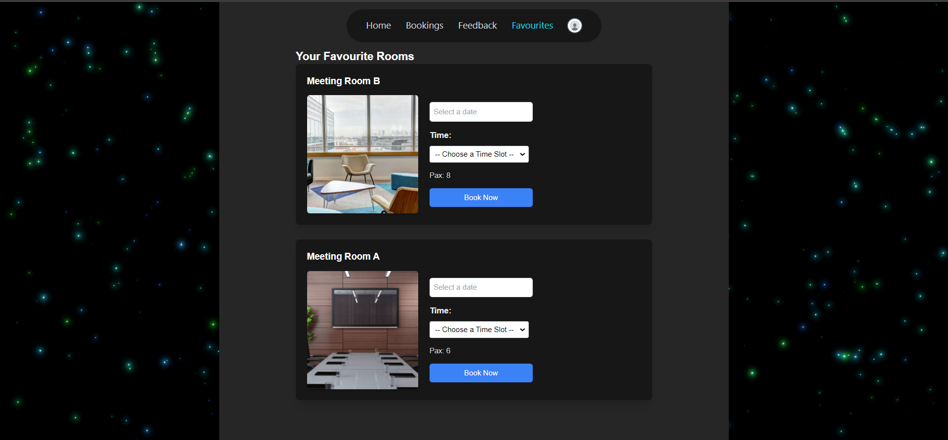
The Favourites menu is where your most preferred rooms are saved to. From here, you can easily book these rooms without having to go through the main page.

4.5.1 Book Room From Favourites
- Fill in the date and time of your selected room.
- Click the blue Book Now button to book on the spot.
- You will be notified about the confirmation.
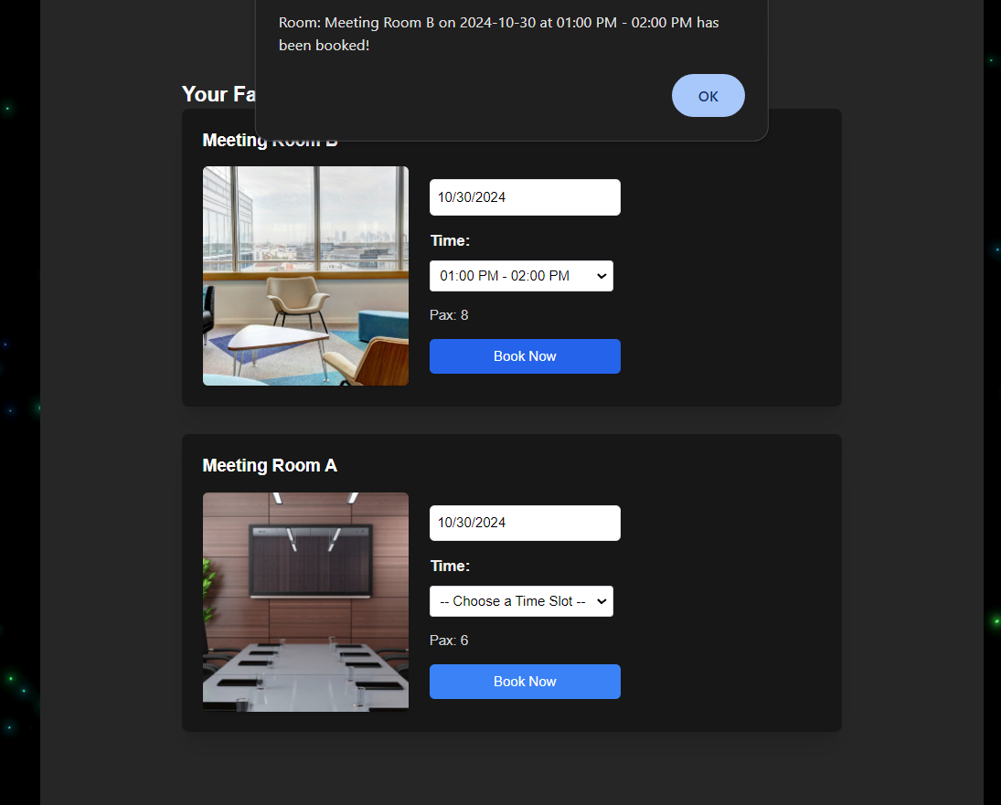

4.6 User/Director Navbar
- Click Home to access the admin menu.
- Click Bookings to access your bookings list.
- Click Feedback to access your feedback about the rooms.
- Click Favourites to access your preferred rooms to book from there.
- Click the icon to access your settings or to logout.
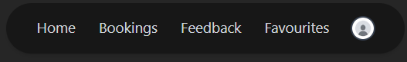

4.6.1 User/Director Settings


4.6.1.1 Change Password
- Click on the blue Change Password button to begin changing your password.

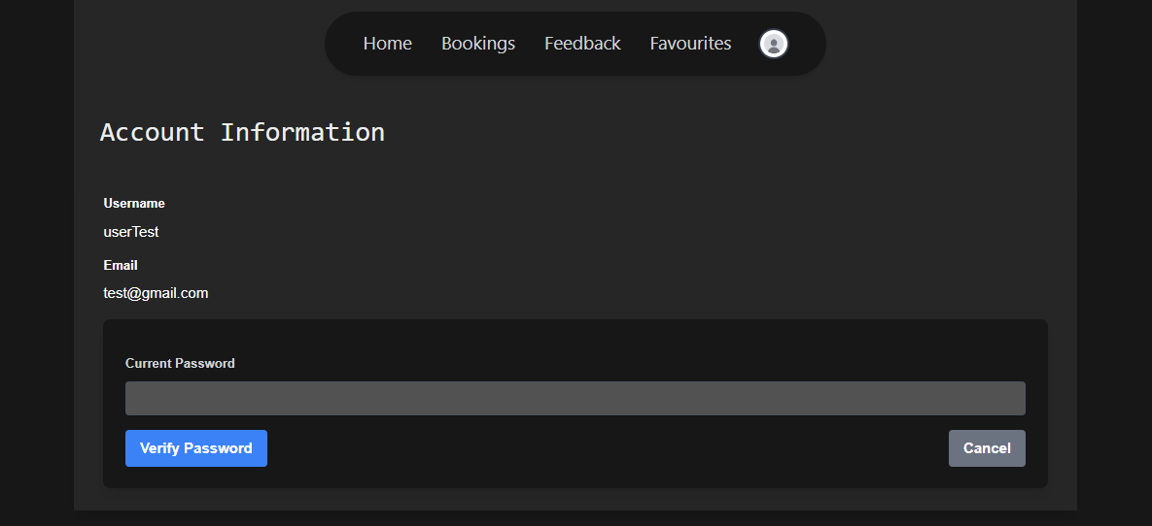
- Click on the blue Verify Password button after entering your password.
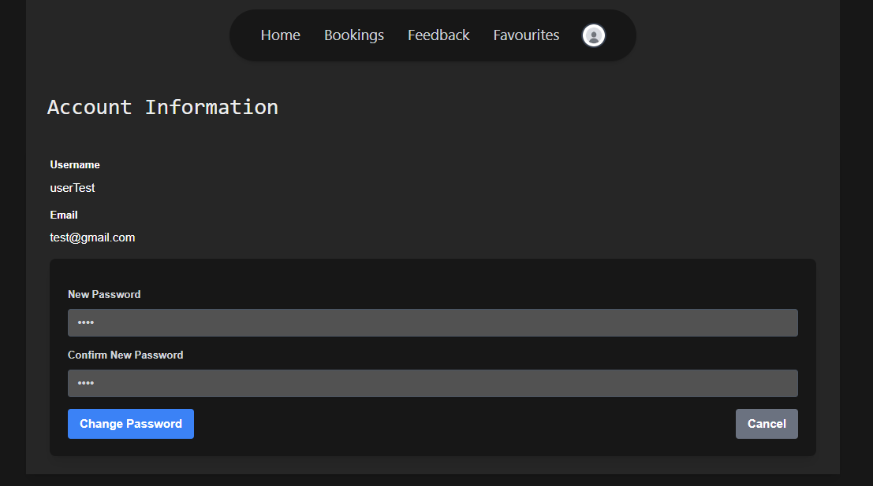
- Enter the new password twice and click the blue Change Password button to make it final.

4.6.2 User/Director Logout
- Click on the Logout button at the bottom of the tab to log out of your account.
- You will return to the login page.
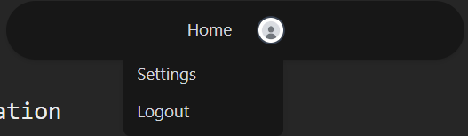

4.7 Mobile Menu
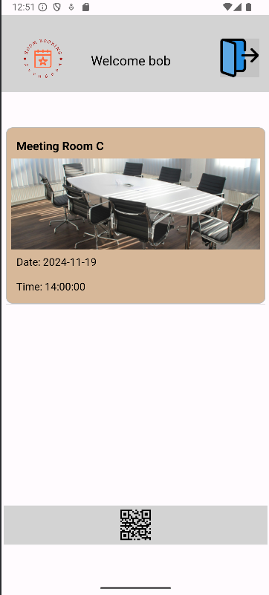

4.7.1 Scan Biometrics
- Tap the QR code icon at the bottom to begin scanning the QR code for the room.
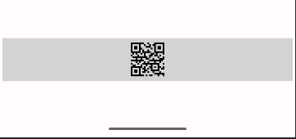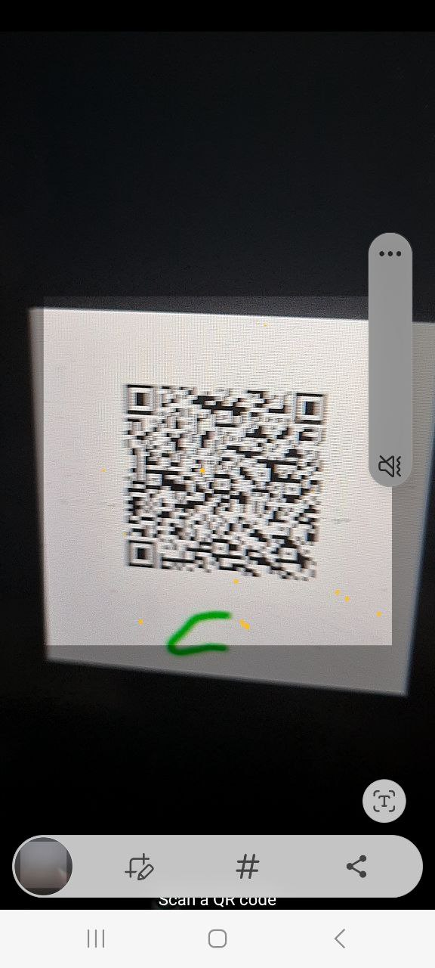
- After that, if it is successful, scan your biometrics next.
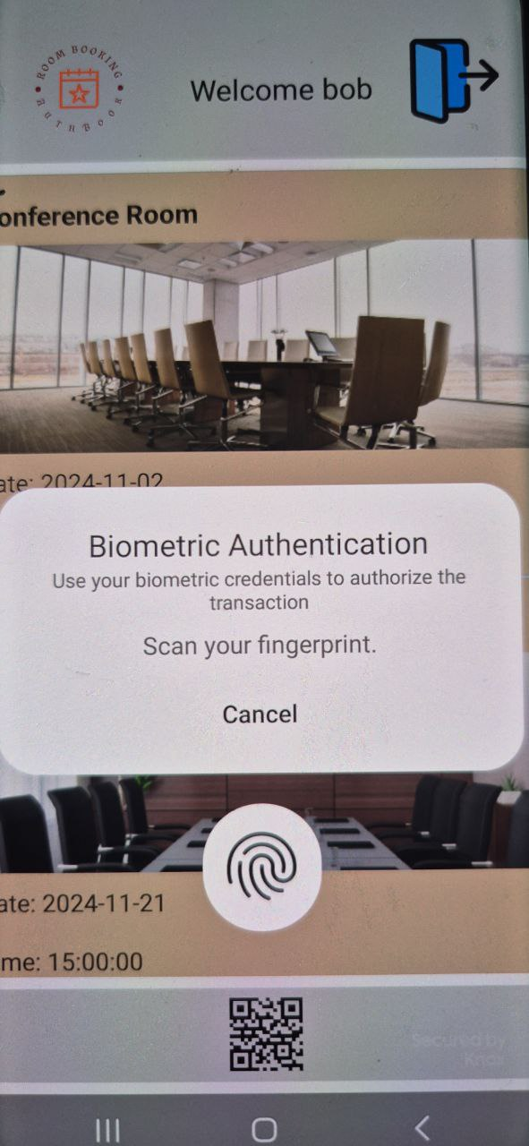
- You will receive a PIN number in your email upon success.
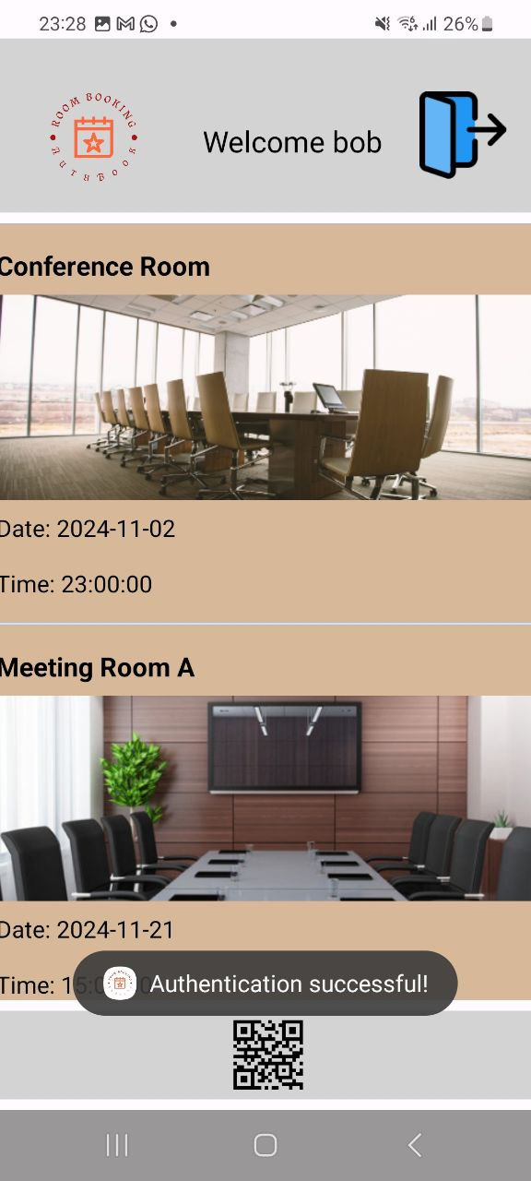

4.7.2 Logout from Mobile
- Tap on the blue door icon at the top of the navbar.
- You will be taken back to the login page.
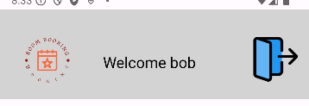

5. How to use Room Booking as an admin

5.1 Admin Login

5.1.1 Admin Webpage Login
- Click the Admin button beside the User button.
- Enter your username and password.
- The notification below the Sign In button will tell you your role, which is admin in this case, and whether the login was a success or not.
- Repeated failures to login will result in the account getting locked out, which means having to contact another administrator to solve this.
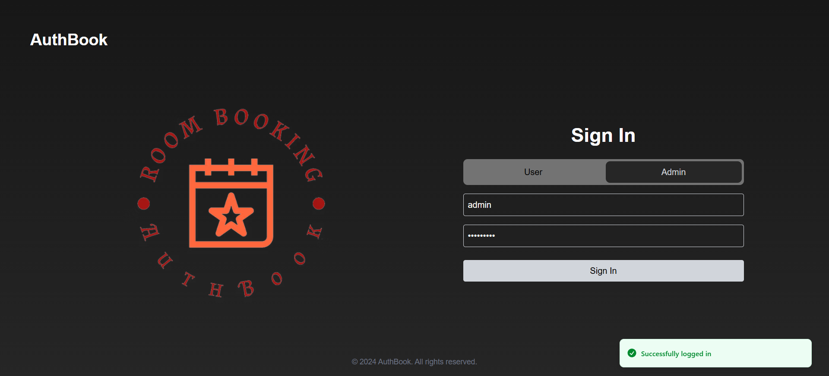

5.1.2 Admin Mobile Login
- Enter your username and password
- Tap the purple Login button.


5.2 Admin Menu
Unlike the user/director menu, the admin menu has a different look.
- The navbar only features the main menu and the account.
- The admin will be able to manage users and rooms.
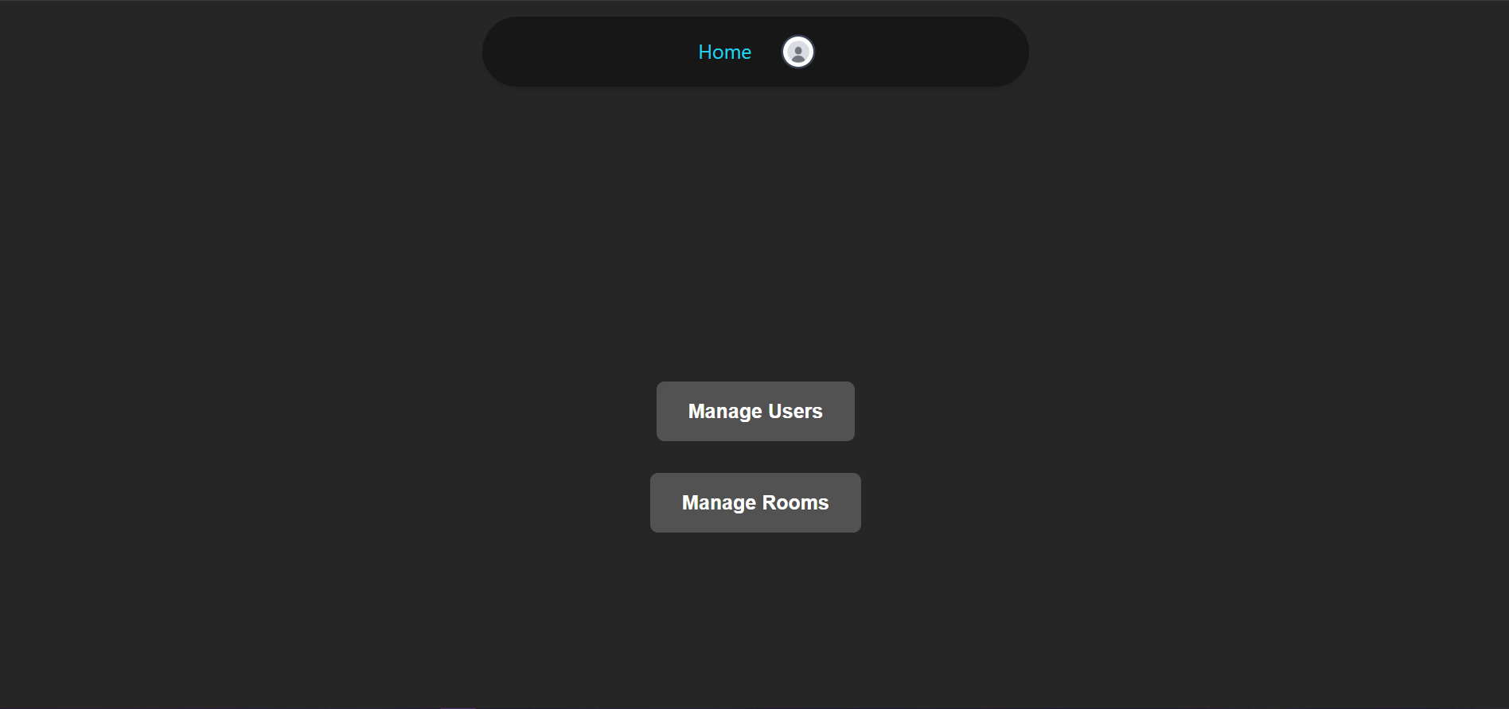

5.3 Admin Navbar
- Click Home to access the admin menu.
- Click the icon to access your settings or to logout.


5.3.1 Admin Settings
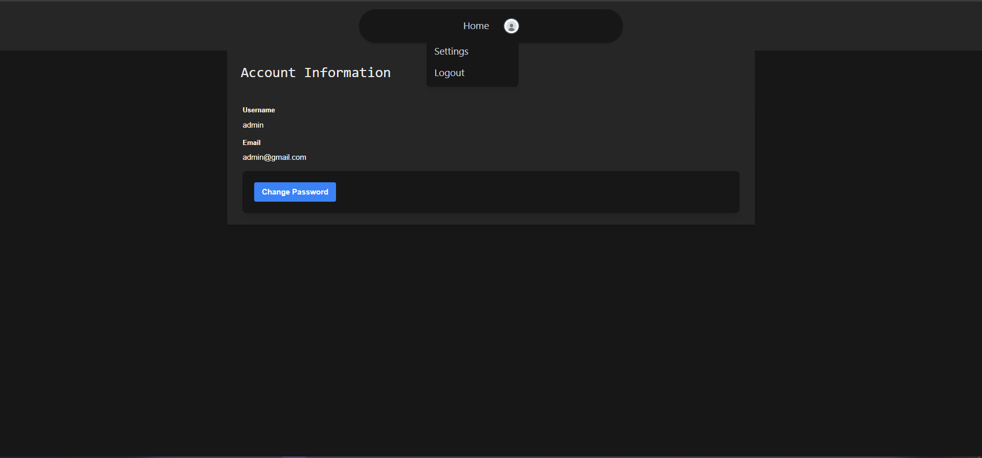

5.3.1.1 Change Password
- Click on the blue Change Password button to begin changing your password.

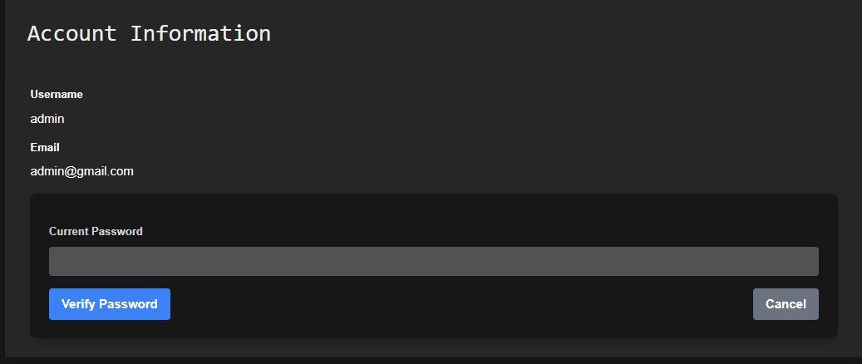
- Click on the blue Verify Password button after entering your password.
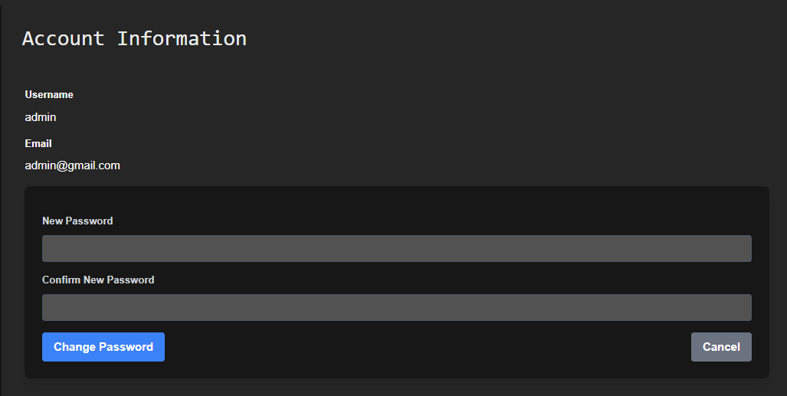
- Enter the new password twice and click the blue Change Password button to make it final.

5.3.2 Admin Logout
- Click on the Logout button at the bottom of the tab to log out of your account.
- You will return to the main menu.


5.4 Admin Manage Users Menu
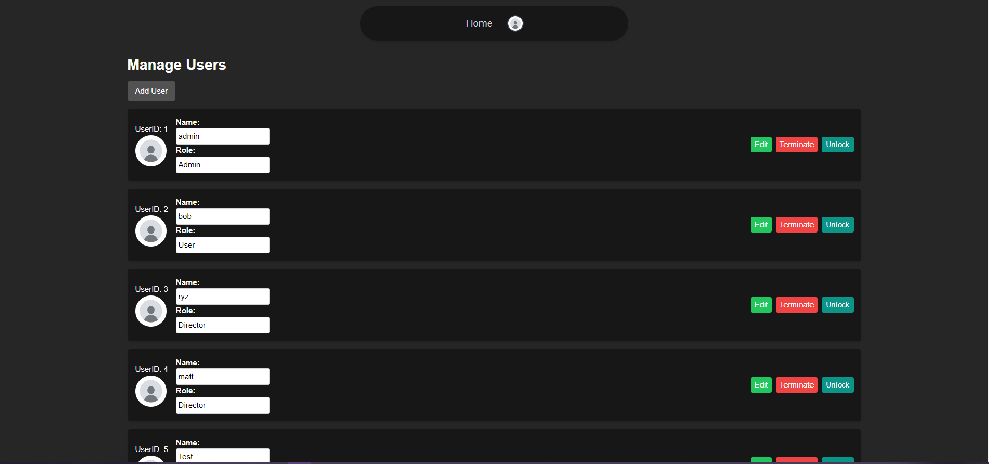

5.4.1 Add User
- Click on the Add User button.
- Enter the new user’s details in the spaces.
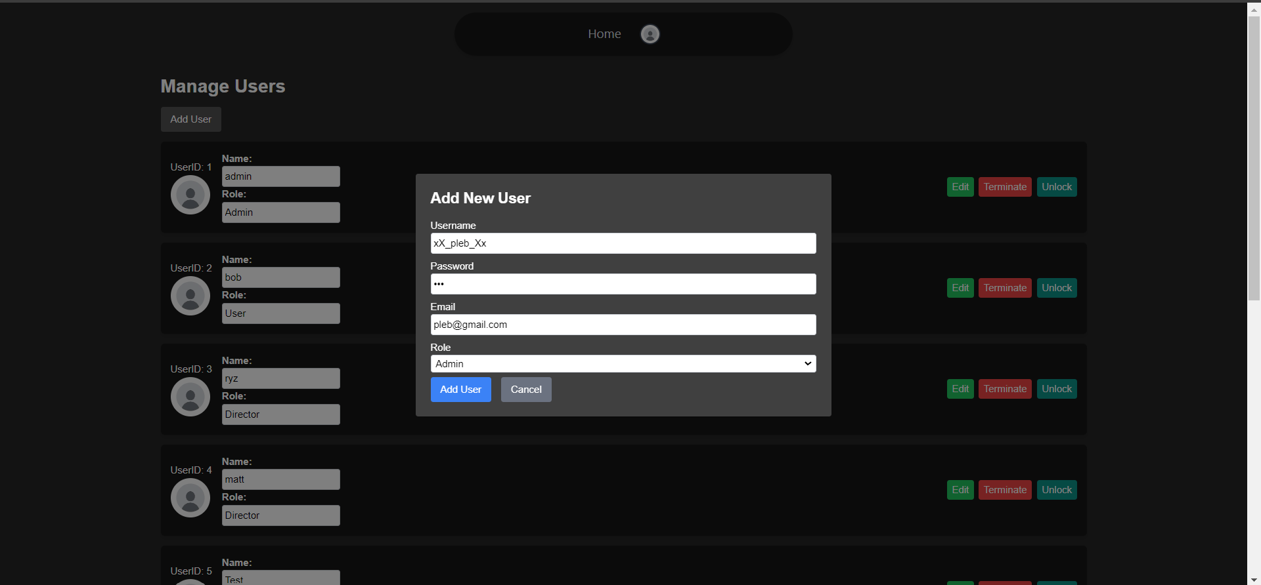
- Click Add User to complete adding the user.
- You will be notified of the addition.
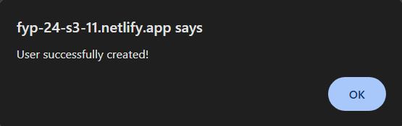

5.4.2 User Management
Click on the respective button at the right of the user to manage them.

5.4.2.1 Edit User
- Click the green Edit button to change username and role.
- Edit Name and Role of the user as you see fit.
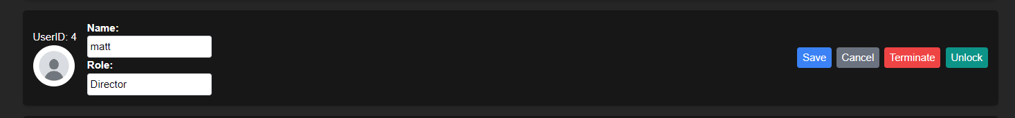
- Click the blue Save button once you are satisfied with the changes made.
- You will be notified of the change made.

5.4.2.2 Terminate User
- Click the red Terminate button to remove a user.
- You will be notified of the user’s removal.
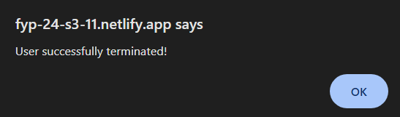

5.4.2.3 Unlock User
- Click the teal Unlock button to unlock a user who has been locked out of their account.
- You will be notified of the unlock and to let the user in question know.
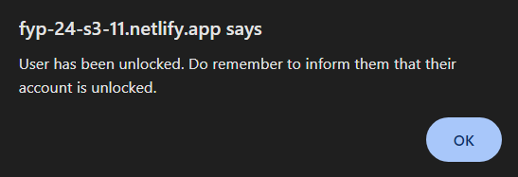

5.5 Admin Manage Rooms Menu
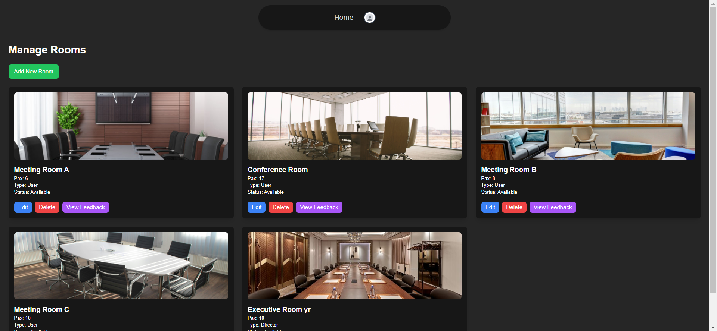

5.5.1 Add Room
- Click on the green Add Room button.
- Enter the new room’s details in the spaces.
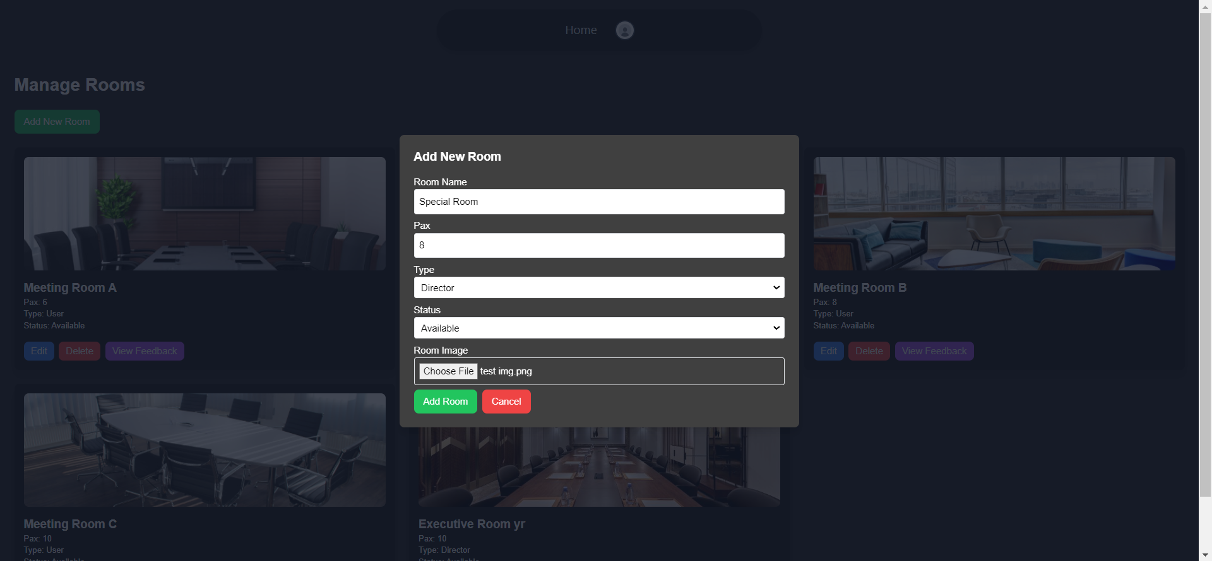
- Click Add Room to complete adding the room.
- You will be notified of the addition.

5.5.2 Room Management

5.5.2.1 Edit Room
- Click the blue Edit button to change the room’s details.
- Edit Room Name, Pax, Type and Status as you see fit.
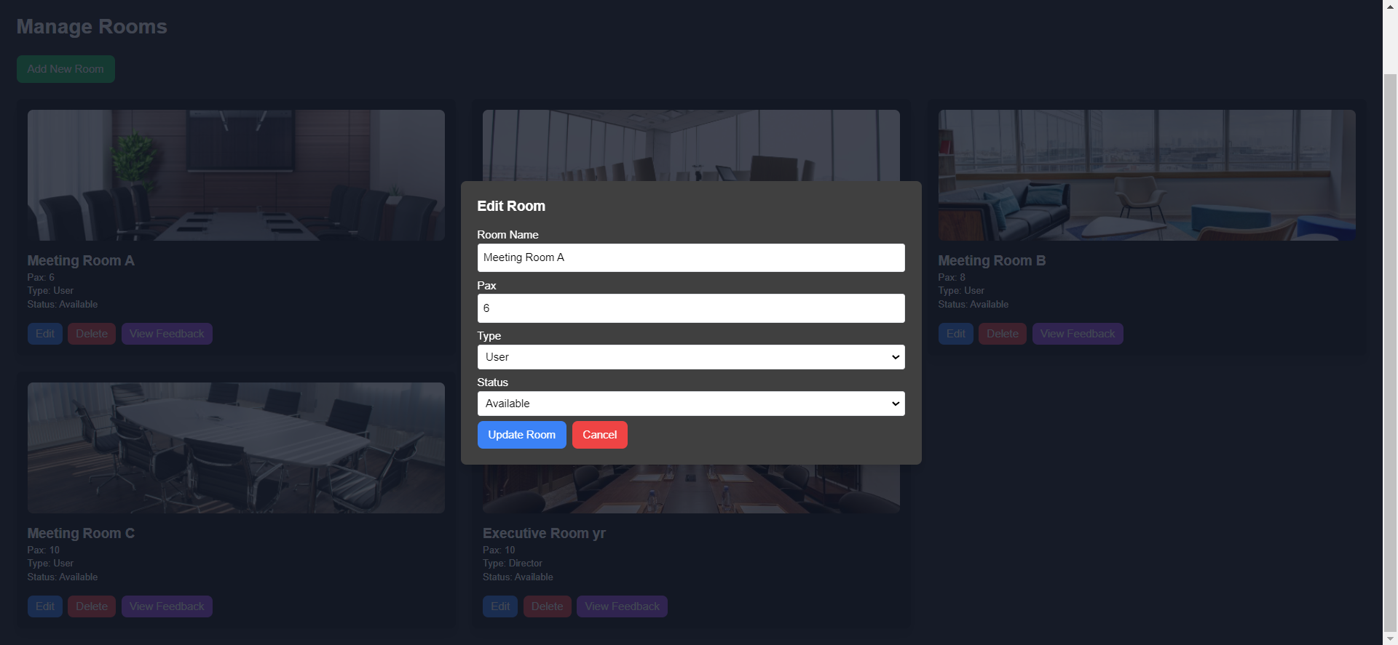
- Click the blue Update Room button once you are satisfied with the changes made.
- You will be notified of the changes made.

5.5.2.2 Delete Room
- Click the red Delete button to remove a room.
- You will be notified of the room’s removal.

5.5.2.3 View Feedback
- Click the purple View Feedback button to view a room’s feedback.
- You will be shown a list of feedback regarding the room.
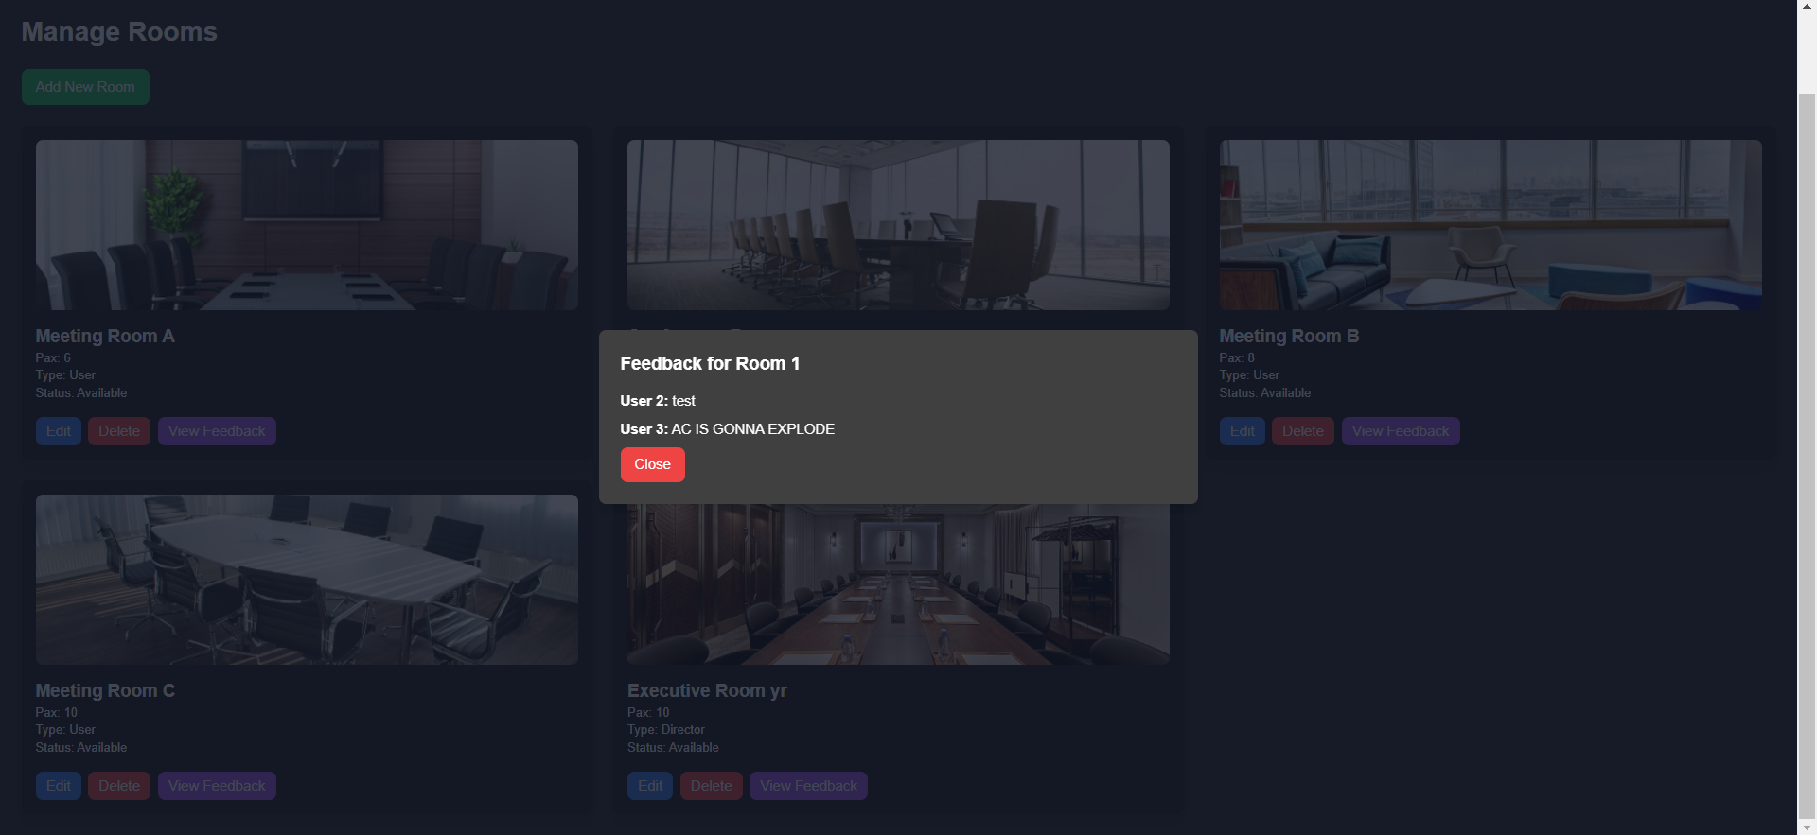
- Click the red Close button once you have read through the feedback.

5.6 Admin Mobile Menu
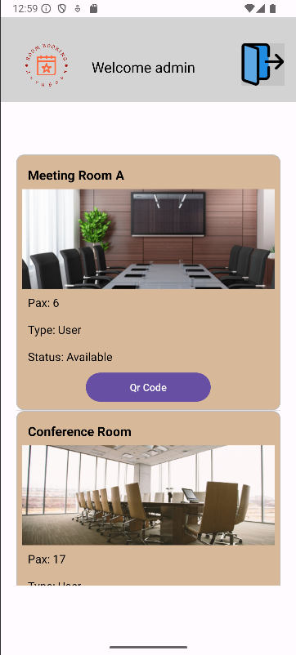

5.6.1 Access QR Code
- Tap on the purple QR Code button below the room card.
- You will be presented with the QR code that users will scan.
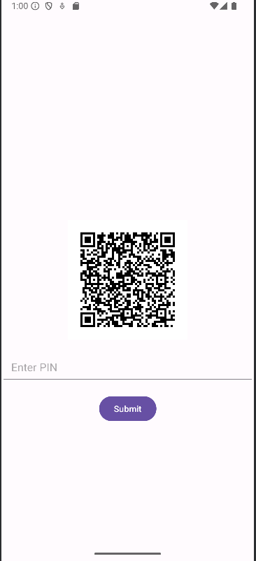

5.6.2 Admin Logout from Mobile
- Tap on the blue door icon at the top of the navbar.
- You will be taken back to the login page.
